

ADDIS ABABA UNIVERSITY

ADDIS ABABA INSTITUTE OF TECHNOLOGY

CENTER OF INFORMATION TECHNOLOGY AND SCIENTIFIC

COMPUTING

**OBSERVING AND EVALUATING WEBSITES**

**FOUND ON INTERNET**

**Prepared By:** -​zekariyas alemu

**Id:** -​Atr/2880/11

March 2020

gg

## **Introduction**

The Internet is the worldwide "network of networks" that links millions of computers together via copper wires, fiber-optic cables, wireless connections, and other telecommunications channels. This publicly accessible network of interconnected computer networks communicate using a set of protocols and standards, the most basic of which are TCP/IP. The Internet has revolutionized the computer and communications world like nothing before. The invention of the telegraph, telephone, radio, and computer set the stage for this unprecedented integration of capabilities. Internet usage has exploded since 1995, based on researcher’s estimation Internet having 1 billion to 1.5 billion users in 2000 and over 3.4 billion in 2016. The most viewed thing on the internet is websites which is a collection of web pages and related content that is identified by a common domain name and published on at least one web server. Notable examples are wikipedia.org, google.com, and amazon.com. The world's first website was published on August 6, 1991 by British physicist Tim Berners-Lee. The number of website As of January 1st, 2020, there were 1,744,517,326 websites, up from 257,601 in January 1996.This number shows a huge release of website per year that’s why people start to evaluate and categorize websites.

# History of internet

No single person invented the Internet. It was the result of years of collaboration among computer scientists, researchers and engineers. Technology experts cite various government agencies as well as a handful of individuals that have played an instrumental role in creating what we know today as the Internet. The history of the Internet has its origin in the efforts to interconnect computer networks that arose from research and development in 1960’s.The major researches are “Galactic Network” concept by J.C.R. Licklider of MIT in 1962 and U.S. military’s research network dubbed Arpanet in 1969.but the Arpanet research was the best because the first successful message was sent from a computer in UCLA to another computer (also called node) at the Stanford Research Institute (SRI). These computers were called Interface Message Processors (IMP).

The Internet has revolutionized the computer and communications world like nothing before. The invention of the electronic devices set the stage for this unprecedented integration of capabilities. But to be in this stage it passes through different stages the table below shows major changes on internet.

Table 1 : events that modify the internet

|  |  |
| --- | --- |
| year | event |
| **1969** | The first message is "LO," was sent from a computer in UCLA to another computer at the Stanford Research Institute (SRI) by Charles Kline |
| **1972** | Ray Tomlinson introduces network email. The next year the term internet born |
| **1974** | The first Internet Service Provider (ISP) is born with the introduction of a commercial version of ARPANET, known as “Tele net” and Vinton Cerf and Bob Kahn publish "A Protocol for Packet Network Interconnection," which details the design of TCP. |
| **1982** | TCP/IP emerge as the protocol for ARPANET |
| **1983** | The Domain Name System (DNS) established |
| **1987** | The number of hosts on the Internet exceeds 20,000. Cisco ships its first router |
| **1990** | Tim Berners-Lee, a scientist at CERN, the European Organization for Nuclear Research, develops Hypertext Markup Language (HTML) the next year they introduces the World Wide Web to the public. These technologies have large impact on the Internet today. |
| **1994** | Yahoo! is created by Jerry Yang and David Filo |
| **1997** | Netflix is founded by Reed Hastings and Marc Randolph as a company that sends users DVDs by mail. |
| **1998** | The Google search engine is born, changing the way users engage with the Internet. |
| **1998** | The Internet Protocol version 6 introduced, to allow for future growth of Internet Addresses |
| **1999** | AOL buys Netscape. Peer-to-peer file sharing becomes a reality as Napster arrives on the Internet, much to the displeasure of the music industry |
| **2003** | The blog publishing platform WordPress is launched. |
| **2004** | Facebook goes online and the era of social networking begins. Mozilla unveils the Mozilla Firefox browser. |
| **2005** | YouTube.com launches. The social news site Reddit is also founded. |
| **2006** | Twitter launches |
| **2010:** | Facebook reaches 400 million active users. Instagram launched. |

# **Observation on some popular websites**

**IMDb (Internet Movie Database)** is an online database of information related to films, television programs, home videos, video games, and streaming content online – including cast, production crew and personal biographies, plot summaries, trivia, fan and critical reviews, and ratings. An additional fan feature, message boards, was abandoned in February 2017. Originally a fan-operated website, the database is owned and operated by IMDb.com, Inc., a subsidiary of Amazon. As of January 2020, IMDb has approximately 6.5 million titles (including episodes) and 10.4 million personalities in its database, as well as 83 million registered users.

Looking of Imbd website in different years

On Dec 21 1998

* Available on Finland, France Hungary, Italy, Norway, Portugal, Sweden, UK, USA .have site maps like SearchtheDatabase,What's *New at* IMDb*?,* SiteIndex …etc.
* Does not have any background picture
* Page title:-welcome to imdb

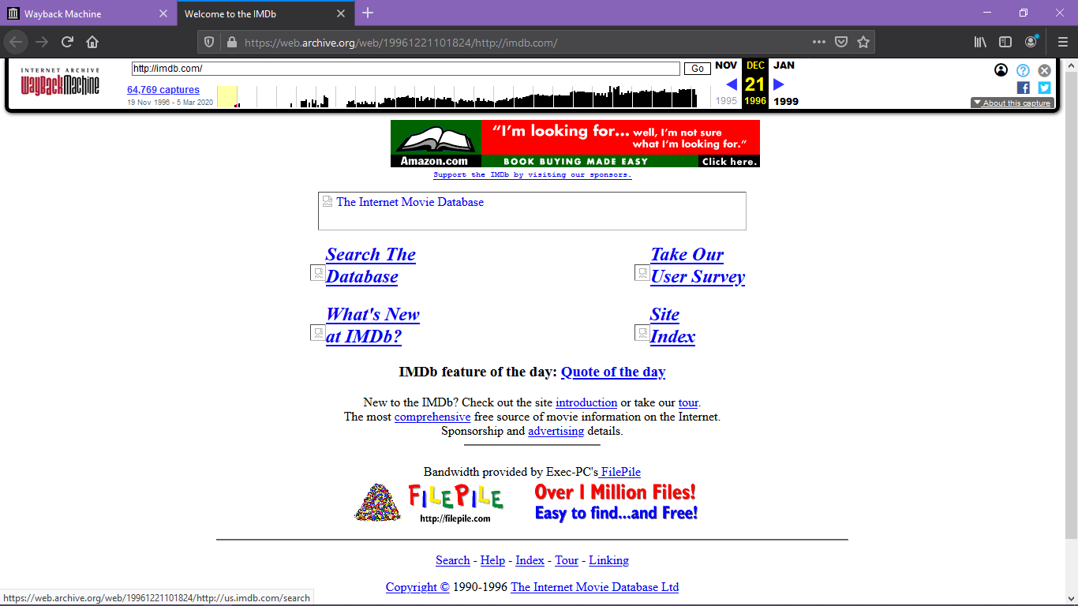

March 30 2001

* Available in three languages
* Have better graphics
* Page title:-the internet movie database

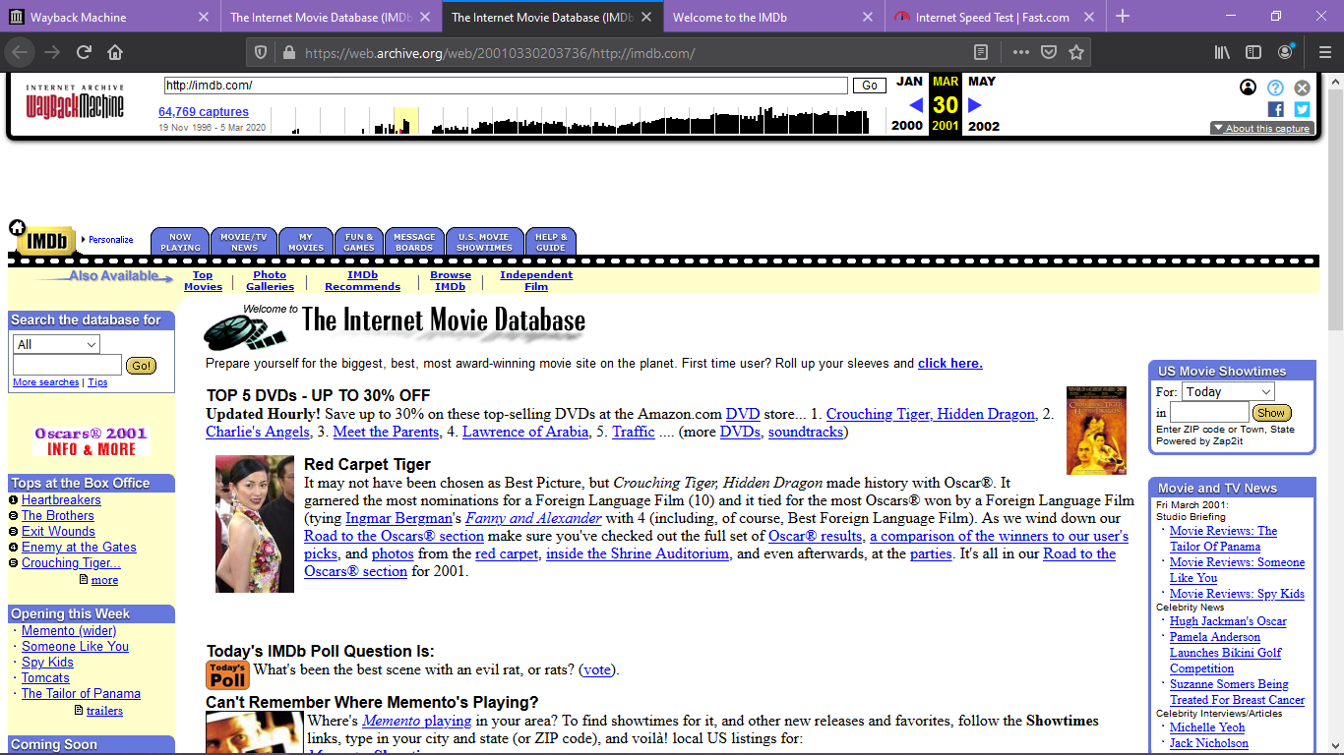

On Oct 03 2010

* Have attractive graphics and news about celebrities added
* Page title:-the internet movie database
* Pro version was added
* Translated to many languages

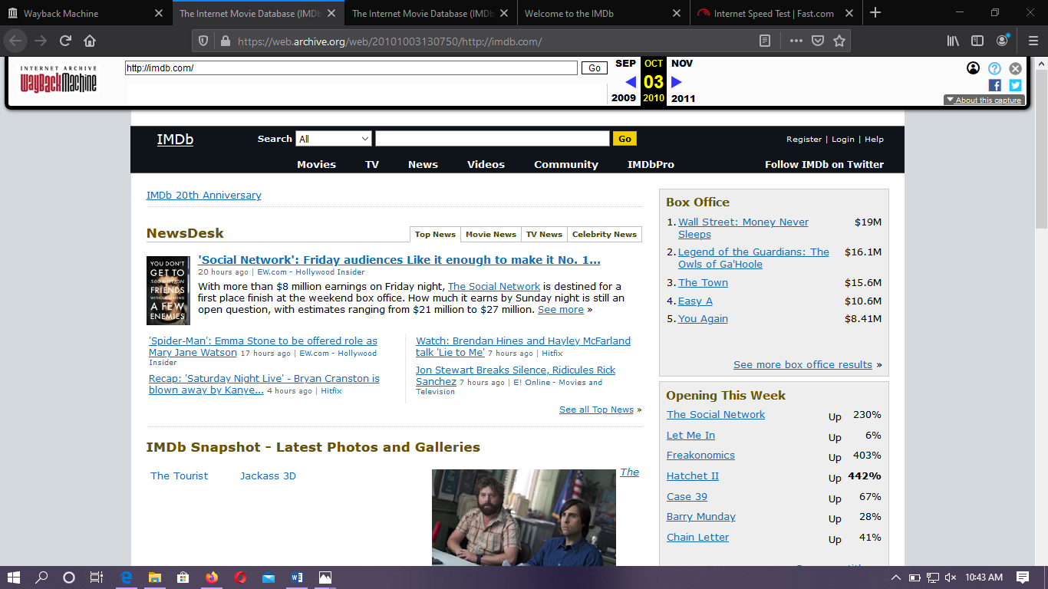

On July 21 2018

* Have a great look and have watch list
* Page title:-Imdb-movies, Tv, celebrities and more...
* Pro version was added

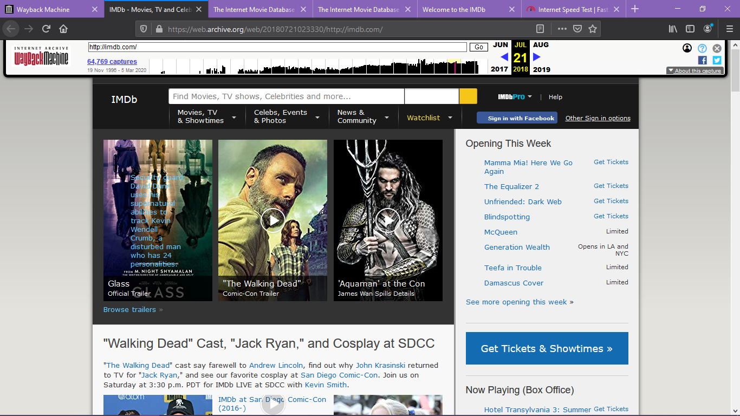

**Goodreads** is a social cataloging website that allows individuals to freely search its database of books, annotations, and reviews. Users can sign up and register books to generate library catalogs and reading lists. They can also create their own groups of book suggestions, surveys, polls, blogs, and discussions. The website's offices are located in San Francisco. The company is owned by the online retailer Amazon.

Goodreads was founded in December 2006 and launched in January 2007 by Otis Chandler and Elizabeth Khuri Chandler. In December 2007, the site had over 650,000 members and over 10,000,000 books had been added.

* The graphics changes through time
* In 2007 it does not have sign up form on the home page
* In 2019 it add love list on the home page

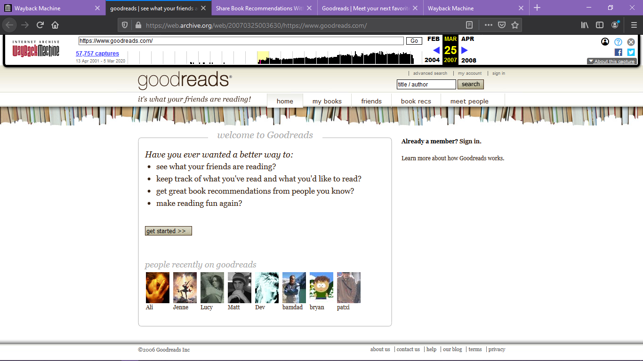

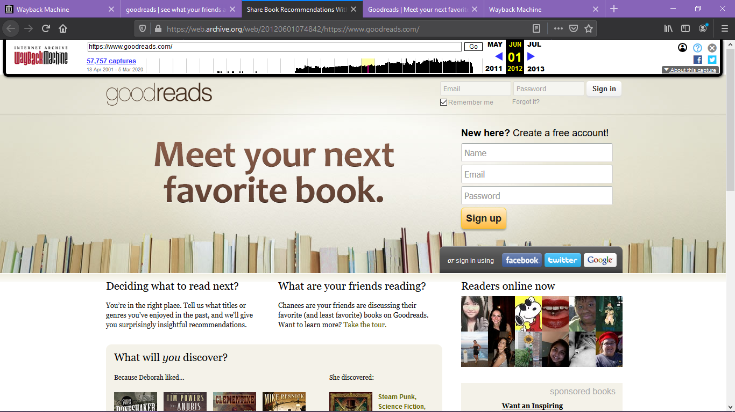

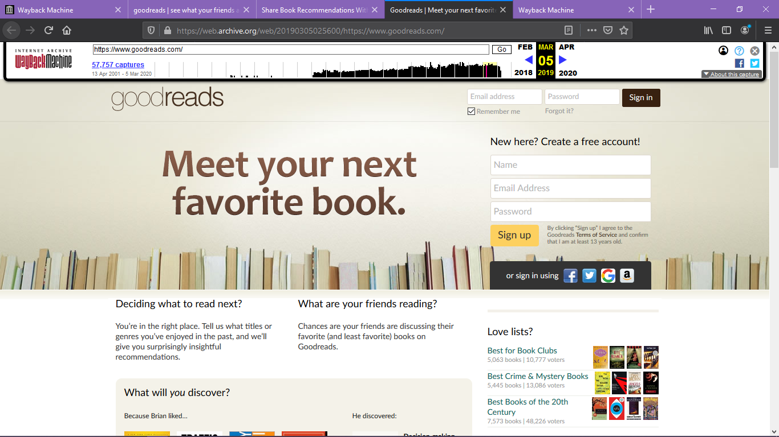

**Amazon** is an American multinational technology company based in Seattle that focuses on e-commerce, cloud computing, digital streaming, and artificial intelligence. Amazon.com was launched in July 1995. The logo was an abstract letter 'A' with a winding river flowing through it and the words Amazon.com, Earth’s biggest bookstore at the bottom.

Amazon is known for its disruption of well-established industries through technological innovation and mass scale. It is the world's largest online marketplace, AI assistant provider, and cloud computing platform as measured by revenue and market capitalization. Amazon was founded by Jeff Bezos in Bellevue, Washington, in July 1994. The company initially started as an online marketplace for books but later expanded to sell electronics, software, video games, apparel, furniture, food, toys, and jewelry.

Looking of amazon website in different years

Feb 29 2000

* The quality is poor
* Use of tabbed navigation
* zShops Was created

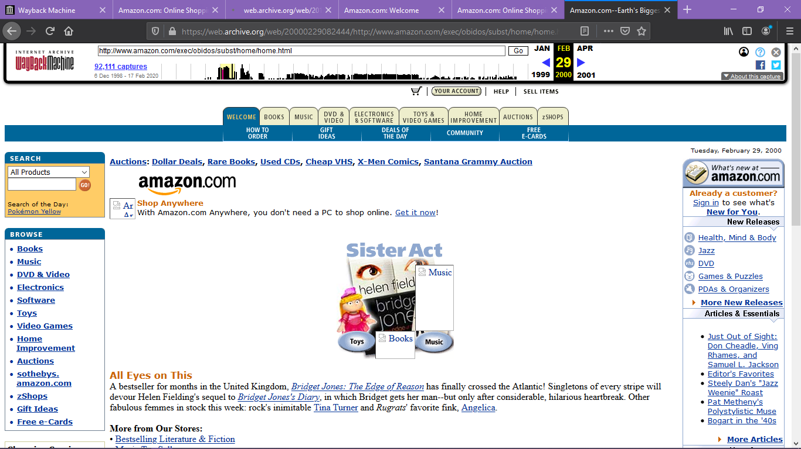

Jan 13 2004

* Amazon added additional categories such as eBooks, baby items, cell phones, and video games
* Some graphic flair added

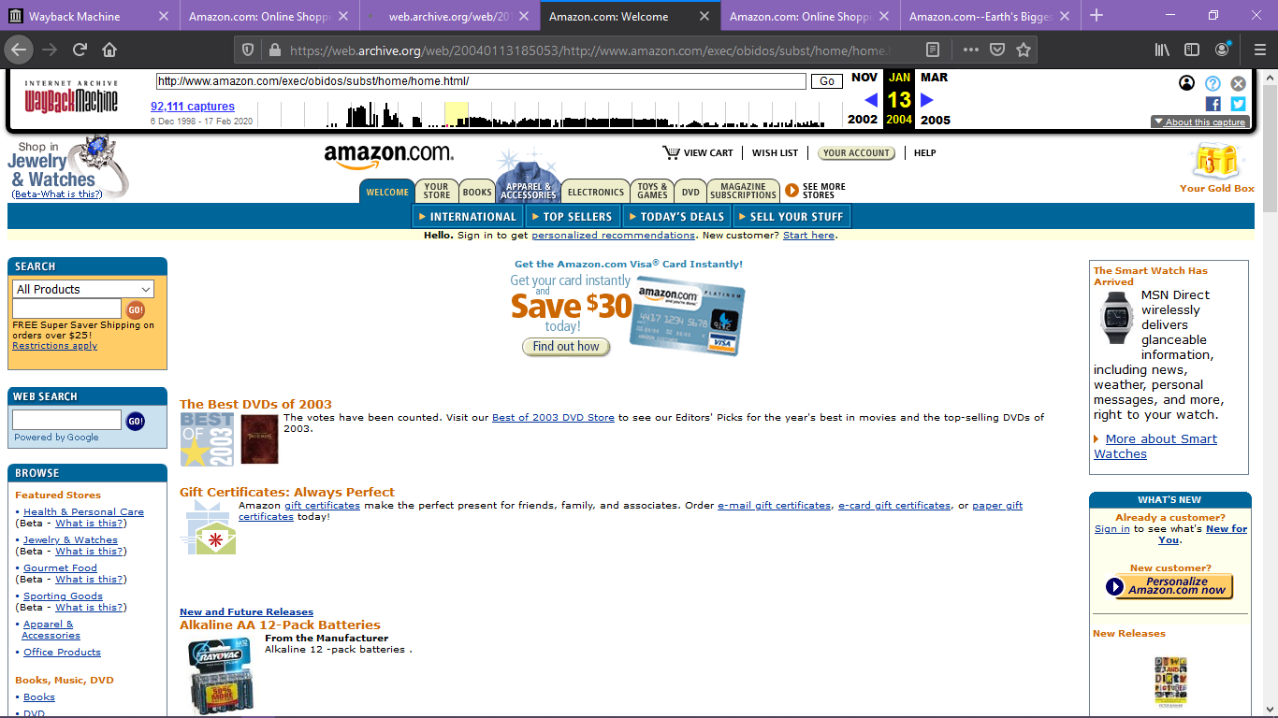

Mar 05 2015

* The homepage moved to a modular design
* Amazon dropped almost all traces of bold colors in the borders and background. Orange fonts were used prominently to show prices and bolded text

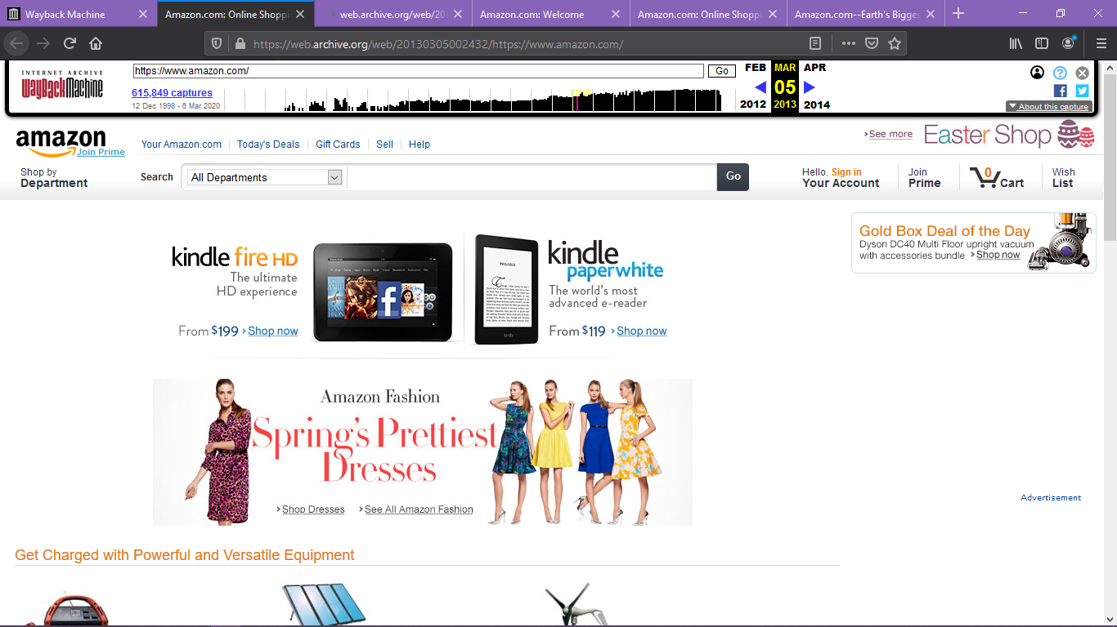

Apr 14 2019

* Transform into a more Spartan look with fewer items for sale on the homepage
* Promotional banner ad at the top of the homepage added

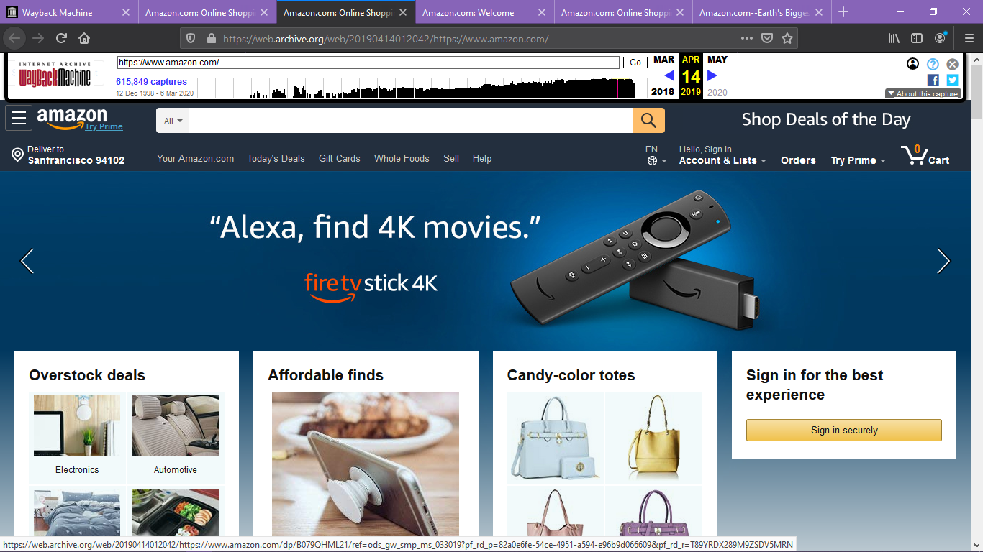

**YouTube** is an American video-sharing platform headquartered in San Bruno, California. Chad Hurley, Steve Chen, and Jawed Karim created the service in February 2005. Google bought the site in November 2006 for US$1.65 billion; YouTube now operates as one of Google's subsidiaries.

YouTube allows users to upload, view, rate, favorites, share, add to playlists, flag, report, comment on videos, and subscribe to other users.

There is tab, graphics, side bar difference between homepage

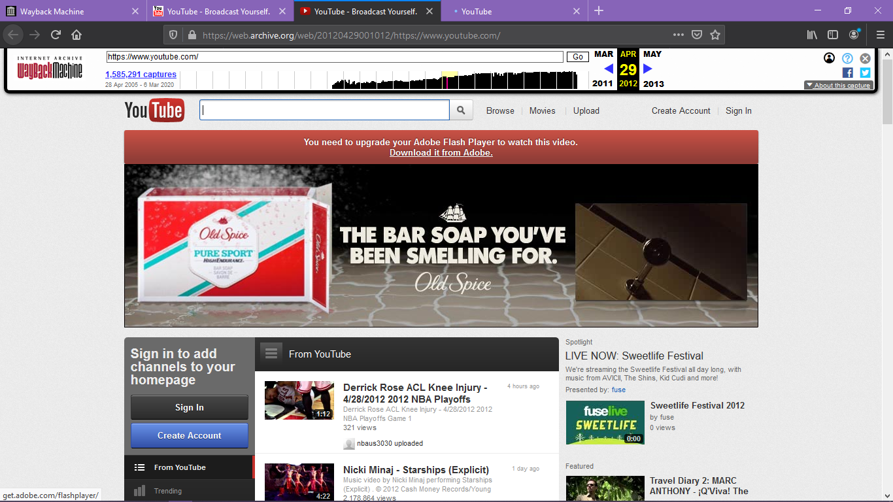

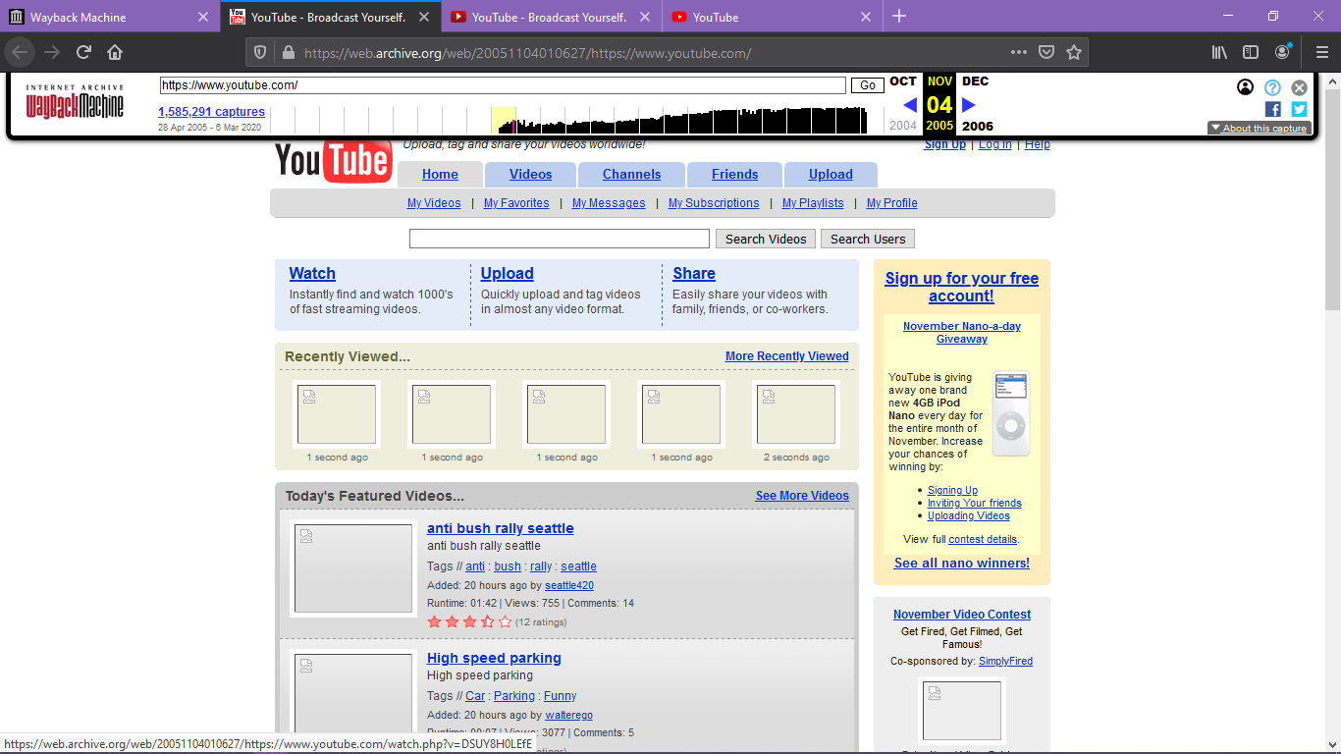

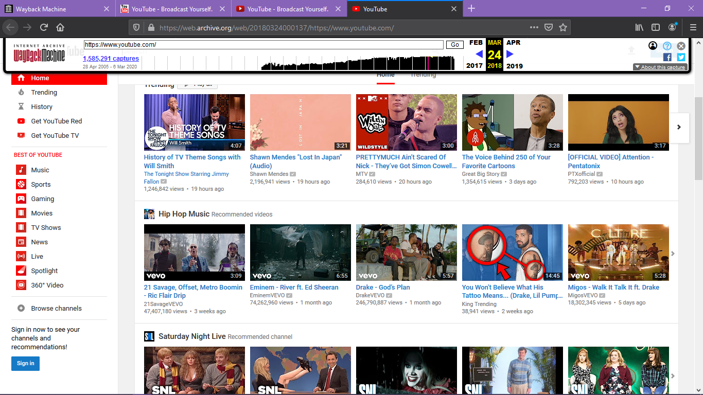

**Facebook** started as just a website for Harvard students by 2005 it was opening up to other schools the profile pages were plain there was also a notification on your profile that said 'this is you'. 2006 was when the mini-fee was born by 2007 anyone who is 13 or with an email could access Facebook. this was also the year that the new feed launched, which meant you could see that all your friends had been doing since the last time you logged in in 2009 Facebook goes mobile by 2010 the website had taken over the world, in 2011 Facebook launched a whole new design .you could add a cover photo since 2011 Facebooks login page and the site hasn't changed a lot

* There is a sign up form on homage except 2010
* Number of entity’s increased in 2015

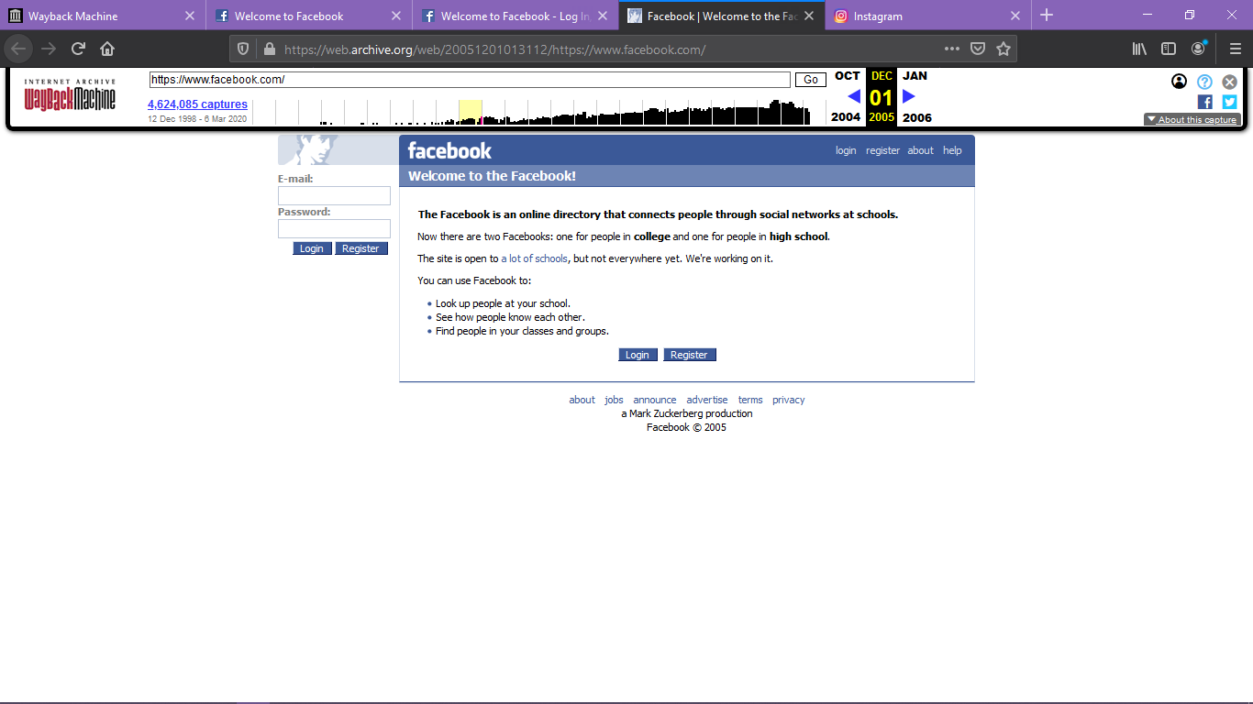

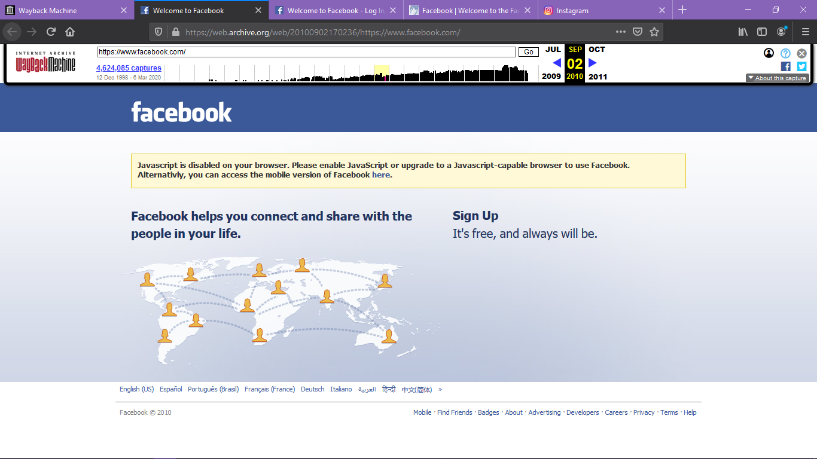

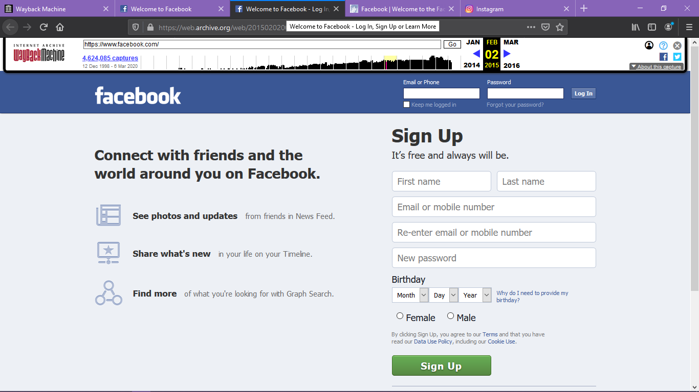

**Instagram** was officially launched in October 2010 and was available exclusively to iPhone users. The concept was simple: an app that lets you add filters to your photos and share them with your social circle.

For over five years, the way Instagram’s feed was filtered remained more or less unchanged. However, in March 2016, the Instagram feed got a total makeover. To reduce missed posts, Instagram officially switched from displaying content chronologically to using an algorithm to sort posts.

May 2016: Instagram unveils a new logo to mixed reactions

August 2016: Stories are added that allow users to share temporary videos and photos with their friends. These Stories are playable for up to 24 hours

* It added sign up form in home page

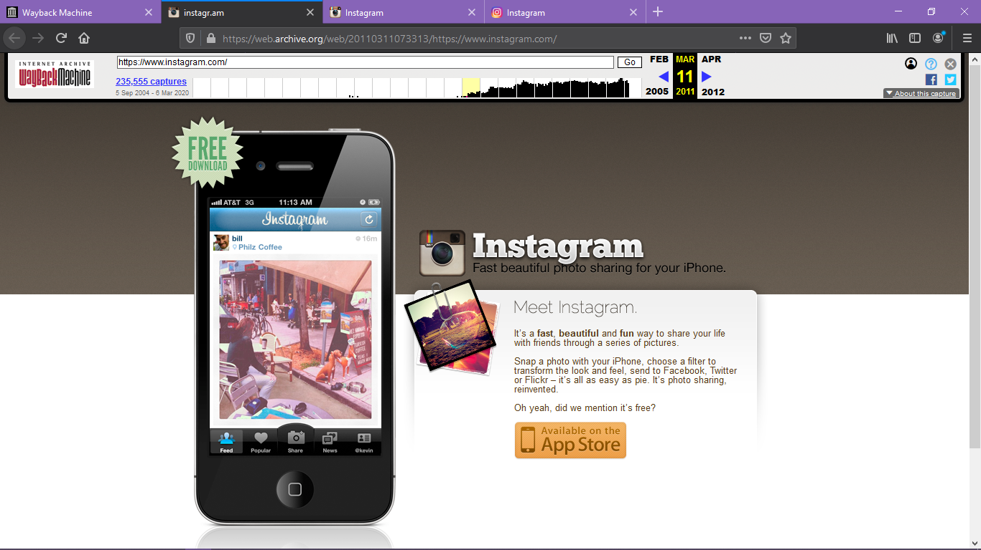

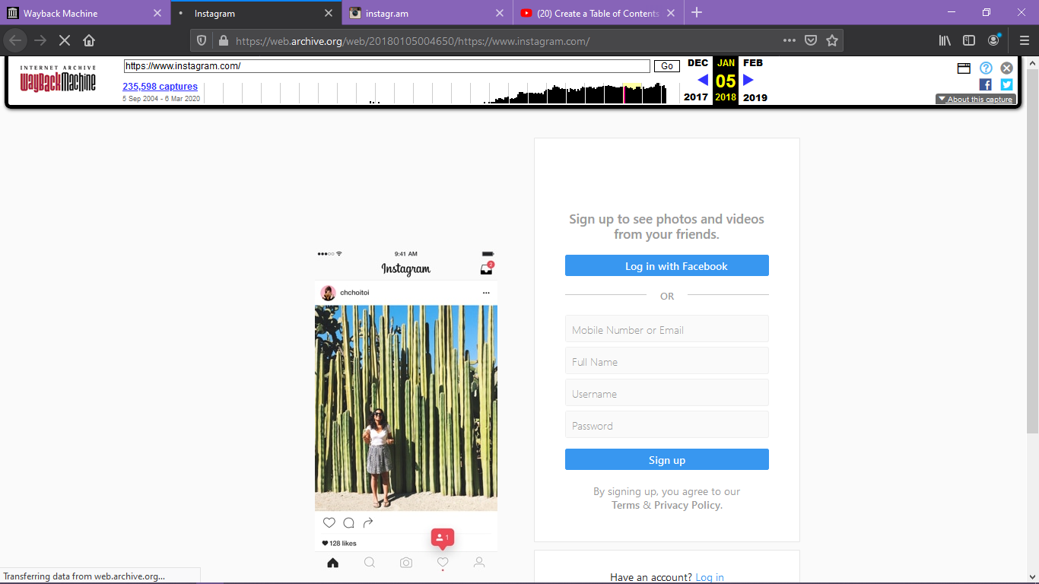

# Categories of website

Paying attention to website design is crucial to building your business. There are now nearly 1.5 billion websites online, which provide a lot of different types of websites to study, but also a lot of confusion over which type and design will actually work best for you, so that why categorizing them is needed.

## 1. Web Portal

Web portals are often websites designed for internal purposes at a business, organization, or institution. They collect information in different formats from different sources into one place to make all relevant information accessible to the people who need to see it. They often involve a login and personalized views for different users that ensure the information that’s accessible is most useful to their particular needs.

|  |  |
| --- | --- |
| Name of the website | URL |
| AAiT portal | <https://portal.aait.edu.et/> |
| Nib bank | <https://www.nibbank.com.et/ARCIB/servlet/BrowserServlet> |
| Gmail | [https://www.google.com/intl/am/gmail/about/#](https://www.google.com/intl/am/gmail/about/) |
| Yahoo mail | <https://login.yahoo.com/> |
| GMX mail | [https://www.gmx.com/#.2831624-header-navlogin2-1](https://www.gmx.com/%23.2831624-header-navlogin2-1) |

## 2. News

The news website is basically an online portal for News channel. They offer latest news headlines on Electronic format. You get all latest updates and notification on your device. There is various News portal present now a day.

|  |  |
| --- | --- |
| Name of the website | URL |
| CNN | <https://edition.cnn.com/> |
| Fox news | <https://www.foxnews.com/> |
| Forbes | [https://www.forbes.com/#633e3ff12254](https://www.forbes.com/%23633e3ff12254) |
| Yahoo news | <https://www.yahoo.com/news/> |
| BBC | <https://www.bbc.com/> |

## 3. Informational

Information websites are websites that answer any question with a quick search. This websites make people not to visit libraries and take out books for basic information that comes into someone’s mind. Nowadays it is often to search on Google to find your answer. A great deal can be learned online and many people are now researching and self-teaching with online tutorials, hacks and tips from such websites.

|  |  |
| --- | --- |
| Name of the website | URL |
| Wikipedia | <https://en.wikipedia.org/w/index.php?search> |
| Quora | <https://www.quora.com/> |
| Google | <https://www.google.com/> |
| Q&A | <https://www.answers.com/> |
| Internet archive | <https://archive.org/> |

## 4. Business Website

A business website is any website that’s devoted to representing a specific business. It should be branded like the business (the same logo and positioning) and communicate the types of products and/or services the business offers. This websites can be shopping websites.

|  |  |
| --- | --- |
| Name of the website | URL |
| Pay pal | <https://www.paypal.com/et/home> |
| Amazon | <https://www.amazon.com/> |
| Ebay | <https://www.ebay.com/> |
| Business insider | <https://www.pulselive.co.ke/bi?r=US&IR=T> |
| Capital one | <https://www.capitalone.com/> |

## 5. Educational Website

Educational websites have the primary goal of either providing educational materials to visitors, or providing information on an educational institution to them.

|  |  |
| --- | --- |
| Name of the website | URL |
| Courser | <https://www.coursera.org/> |
| Edx | <https://www.edx.org/> |
| Chegg | <https://www.chegg.com/> |
| W3school | <https://www.w3schools.com/> |
| Khan acadamey | <https://www.khanacademy.org/> |

## 6. Entertainment Website

Entertainment website is a website which people can entertain. And it is one of the best ways to get that content out into the world.

Most of these websites do aim to make money like business and e-commerce websites do, but usually through the advertisements that show up on the page rather than through selling specific products or services.

|  |  |
| --- | --- |
| Name of the website | URL |
| Netflix | <https://www.netflix.com/et/> |
| Entertainment tonight | <https://www.etonline.com/> |
| King | <https://king.com/> |
| Hollywood | <https://www.hollywood.com/> |
| Tmz | <https://www.tmz.com/> |

## 7. Advocacy website

Advocacy websites that seeks to ensure that people, particularly those who are most vulnerable in society, to able to:

* Have their voice heard on issues that are important to them.
* Defend and safeguard their rights.
* Have their views and wishes genuinely considered when decisions are being made about their lives.

|  |  |
| --- | --- |
| Name of the website | URL |
| World advocacy | <http://www.worldadvocacy.com/> |
| Green peace | <https://www.greenpeace.org/global/> |
| On smoking | <https://ash.org/> |
| UN DO IT | <http://www.undoit.org/> |
|  |  |

## 8. Blogs

A blog website has features regularly updated articles, photos and videos. Blogs started with more casual, personal content compared to magazines. But since then, the lines have blurred, and now it’s extremely common for major brands and businesses to have their own blog. Adding expert content improves the overall credibility of a company or an individual. Blogs also provide material for social media posts and email campaigns.

|  |  |
| --- | --- |
| Name of the website | URL |
| Blogger | [https://www.blogger.com/blogger.g#welcome](https://www.blogger.com/blogger.g%23welcome) |
| Bloglovin | <https://www.bloglovin.com/> |
| Twitter | <https://twitter.com/> |
| Pinterest | <https://www.pinterest.com/> |
| Life hacker | <https://lifehacker.com/> |

## 9. Wiki

A wiki is any website where various users are able to collaborate on content and all make their own tweaks and changes as they see fit. There are wikis for fan communities, for business resources, and for collecting valuable information sources.

|  |  |
| --- | --- |
| Name of the website | URL |
| Wikipedia | <https://en.wikipedia.org/wiki/Main_Page> |
| Encyclopedia | <https://www.encyclopedia.com/> |
| Wikihow | <https://www.wikihow.com/Main-Page> |
| Answer | <https://www.answers.com/> |
| Quora | <https://www.quora.com/> |

## 10. Social Network websites

Social network websites are web‐based services that allow individuals to construct a public or semi‐public profile within a bounded system, articulate a list of other users with whom they share a connection, and view and traverse their list of connections and those made by others within the system.

|  |  |
| --- | --- |
| Name of the website | URL |
| Instagram | <https://www.instagram.com/> |
| Skype | <https://www.skype.com/en/> |
| Facebook | <https://www.facebook.com/> |
| LinkedIn | <https://www.linkedin.com/> |
| Messenger | <https://www.messenger.com/> |

## 11. Content aggregator websites

A content aggregator is a website that gathers web **content** (and/or sometimes applications) from different online sources for reuse or resale. They come in two kinds: Those who simply gather **news** from various sources for their websites. Those who gather and distribute **news** for customers.

|  |  |
| --- | --- |
| Name of the website | URL |
| Feedly | <https://feedly.com/i/welcome> |
| Panda | [https://usepanda.com/app/#/](https://usepanda.com/app/%23/) |
| The web list | <https://theweblist.net/> |
| Popurls | <http://popurls.com/> |
| Best reddit list | [https://www.doublemesh.com/](https://www.doublemesh.com/best-reddit-subreddits-ui-ux-designers/) |

## 12. Personal Website

personal websites are websites people develop them to put their own thoughts personal blogs, vlogs, and photo diaries to share with the world.

|  |  |
| --- | --- |
| Name of the website | URL |
| Personal website of niashanks | <https://www.niashanks.com/> |
| Personal website of simonsinek | <https://simonsinek.com/> |
| Personal website of /ellensriley | <http://ellensriley.com/> |
| Personal website of timharford | <http://timharford.com/> |
| Personal website of joshuamccartney | <https://www.joshuamccartney.com/> |

# Evaluating website

Because of many websites on the Internet, it is very important you develop evaluation skills to assist you in identifying quality Web pages.  There are criteria that should be applied when evaluating any Website. For each criterion, there are several questions to be asked.  If most of the questions have answer "yes", the more likely the Web site has greater quality.

### **1. AUTHORITHY**

* The name of the individual or group creating the site should be clearly stated.
* The Web site author or manager should provide contact information for users to make comments or ask questions.
* Sites that clearly violate copyright statutes or other laws should not be linked, listed, or recommended.

### **2. ACCURACY**

There are few standards to verify the accuracy of information on the web. It is the responsibility of the reader to assess the information presented. Evaluating a web site for accuracy:

* Are the sources for factual information clearly listed so they can be verified in another source?
* Is the information free of grammatical, spelling errors?
* Is a bibliography or reference list included?

### **3. OBJECTIVITY**

* Does the content appear to contain any evidence of bias?
* Is there a link to a page describing the goals or purpose of the sponsoring organization?
* If there is any advertising on the page, is it clearly differentiated from the informational content?

### **4. CURRENCY**

Currency of the site refers to how current the information presented is, and how often the site is updated or maintained. It involves finding the date information was: first written, placed on the web and last revised

Then ask if:

* Links are up-to-date and should be reliable. Dead links or references to sites that have moved are not useful
* .Information provided so trend related that its usefulness is limited to a certain time period?

### **5. CONTENT**

* A site's content should be comprehensible, appropriate, and of value to the intended audience.
* There should be enough information to make visiting the site worthwhile. Information on how often the site is visited may indicate its usefulness.
* Although there may be variations in how information is ordered, the organization should generally be logical.
* Sites that promote social biases should be rejected or critically reviewed.
* If there are large amounts of information on the site, there should at least be a site map or outline of topics that allows users to find topics and move among them easily. A search function for locating information within the site would also be useful.
* The information should be current, accurate, and regularly updated. A "last updated" notification is a useful feature.
* Copyright information is useful if you anticipate copying a substantial amount of the content for dissemination.
* Links to more information on the topic should be provided.
* Graphics should be relevant and appropriate to the content.

### **6. PURPOSE**

Evaluating a web site for purpose is asking the following question

* Does the content support the purpose of the site?
* Is the information geared to a specific audience (students, scholars, general reader)?
* Is the site organized and focused?
* Are the outside links (SEO) appropriate for the site?
* Does the site evaluate the links?

### **7 User-friendly**

* Usability: Website is easy to use, understand, operate, find information, or navigate
* Reliability: Website’s address is appropriate and easy to remember, short download time multi browser support work properly using different screen Settings, few ads are in the website’s pages, there is a way to measure its efficiency and the website is available 24/7.
* Interactive features: Try to see if the website has clear instructions to use different forms, help function and clear error messages are available and feedback exist between user and website through email, chat rooms.

#### Evaluation of chess.com

Chess.com is an internet chess server, internet forum and social networking website; it is also the name of the company that runs the site. It is the most frequently visited chess website, according to Alexa Internet rankings according to the above guidelines let’s evaluate it

##### Authority

* + owned by the company chess.com It is certified and The certificate was issued by Sectigo
  + There is no any link that violates copyright
  + Have commenting page but You need to sign in to play and comment

##### Accuracy

* + it is free from grammatical and spelling error
  + It asks you to verify your account through the email you use

##### Objective

* The content is based on evidence and it’s a fair game
* Have a link that explain the purpose of sponsoring organization
* Advertising is differentiated from the playing pages by the word ad

##### Currency

* Links are up to date

##### Content/coverage

* The site content is appropriate it won the award as the best chess of 2014
* Have information how many time the page visited per day
* It is free from social biases
* Have site maps and search function
* It notify you when information are updated
* Have copyright information at the footer
* It have green by dark white chess board

##### Purpose

* Its purpose is to let people play chess online and learn about chess
* The content support the purpose of the site
* It is well organized and focused
* Outside links are easy to discover because

1. page title is less than 60 characters
2. meta description is around 120 characters

* According to the owner they evaluate every link in the website

##### User friendly

* It easy to use and best on mobile
* It is very easy to remember the address
* It have chat room and comment box to feedback, also it have clear instruction

Over all it’s a great site that from the evaluation by the above guideline it will get 23/25.

#### Evaluation of premierLeague.com

Chess.com is an internet chess server, internet forum and social networking website; it is also the name of the company that runs the site. It is the most frequently visited chess website, according to Alexa Internet rankings according to the above guidelines let’s evaluate it

##### Authority

* + owned by the company Barclays and football association of premier league
  + There is no any link that violates copyright
  + Have contact page to comment and ask question

##### Accuracy

* + it is free from grammatical and spelling error
  + It asks you to verify your account through the email you use when you are signing up

##### Objective

* The content is based on match
* Have a link that explain the goal of sponsoring organization

##### Currency

* Links are up to date

##### Content/coverage

* The site content is appropriate
* Have information how many time the page visited
* It is free from social biases
* Have site maps and search function
* It notify you when information are updated
* Have copyright information at the footer
* Have attractive graphics

##### Purpose

* Its purpose is to let people have information about premier league
* The content support the purpose of the site
* It is well organized and focused
* Outside links are a little weak to discover because
  + page title is greater than 60 characters
* According to the owner they evaluate every link in the website

##### User friendly

* It easy to use and best on mobile
* It is very easy to remember the address
* It have chat room and comment box to feedback, also it have clear instruction

Over all it’s a good site that from the evaluation by the above guideline it will get 22/25.

# Conclusion

To finalize website are collection of web pages that are most viewed on internet. Today there are around 1.5 billion websites on internet so it need to be categorized and evaluated. Social network websites and Entertainment Website are the most known and used categories.

# **Reference**

[**www.networkworld.com**](https://www.networkworld.com/article/2870267/the-evolution-of-the-internet.html)

[**en.wikipedia.org**](https://en.wikipedia.org/wiki/History_of_the_Internet)

[**www.internetsociety.org**](https://www.internetsociety.org/internet/history-internet/brief-history-internet/)

[**https://www.hostgator.com/blog/popular-types-websites-create/#10_Personal_Website**](https://www.hostgator.com/blog/popular-types-websites-create/#10_Personal_Website)

[**https://web.archive.org/**](https://web.archive.org/)

[**https://ccconline.libguides.com**](https://ccconline.libguides.com)

[**https://lib.nmu.edu**](https://lib.nmu.edu)